“CODETRACE: INSIDE LINUX PROCESS AND SYSTEM CALL’S ”
A Project Report Submitted in the partial fulfillment of the requirements for the award of the degree of

BACHELOR OF TECHNOLOGY
In

DEPARTMENT OF COMPUTER SCIENCE ENGINNERING

By

SIRPURI HARSHITH 2520030572

MIRYALA THARAVARSHINI 2520030052

PRATHYUSHA REDDY 2520030612

SAI KRISHNA.K 2520030610

Under the Esteemed Guidance of

Dr. K. HEMA
Assistant Professor
Department of Computer Science and Engineering




K L (Deemed to be) University DEPARTMENT OF COMPUTER SCIENCE ENGINEERING
&

DEPARTMENT OF COMPUTER SCIENCE AND INFORMATION TECHNOL

Declaration

The Project Report entitled “Codetrace: Linux processes & System’s call’s” is a record of Bonafide work of SIRPURI HARSHITH - 2520030572 , THARA VARSHINI - 2520030052, T.PRATHYUSHA REDDY – 2520030612 , K.SAI KRISHNA - 2520030610 submitted in partial fulfillment for the award of B. Tech in Computer Science and Engineering (or) Computer Science and Information Technology to the K L University. The results embodied in this report have not been copied from any other departments/University/Institute.

SIRPURI HARSHITH 2520030572

M.THARA VARSHINI 2520030052

PRATHYUSHA REDDY 2520030612

K.SAI KRISHNA 2520030610

K L (Deemed to be) University

DEPARTMENT OF COMPUTER SCIENCE ENGINEERING

CERTIFICATE

This is certify that the mini project based report entitled “Codetrace: linux processes & System call’s” is a bonafide work done and submitted by SIRPURI HARSHITH – 2520030572,
in partial fulfillment of the requirements for the award of the degree of BACHELOR OF TECHNOLOGY in Department of Computer Science Engineering, K L (Deemed to be University), during the academic year 2026-2027.

Signature of the Guide

Signature of the Course Coordinator Signature of the HOD

ACKNOWLEDGEMENT
The success in this project would not have been possible but for the timely help and guidance rendered by many people. Our wish to express my sincere thanks to all those who has assisted us in one way or the other for the completion of my project.

Our greatest appreciation to my Course Coordinator Dr. K. Anusha, and my guide Dr K.HEMA, Department of Computer Science which cannot be expressed in words for his/her tremendous support, encouragement and guidance for this project.

We express our gratitude to Dr. P Venkateshwara Roa (CSE), Head of the Department for Computer Science Engineering for providing us with adequate facilities, ways and means by which we are able to complete this project-based Lab.

We thank all the members of teaching and non-teaching staff members, and also who have assisted me directly or indirectly for successful completion of this project. Finally, I sincerely thank my parents, friends and classmates for their kind help and cooperation during my work.

SIRPURI HARSHITH 2520030572

M.THARA VARSHINI 2520030052

PRATHYUSHA REDDY 2520030612

K.SAI KRISHNA 2520030610

Abstract

The project focuses on debugging Linux programs and processes to identify programming errors, runtime failures, abnormal behavior, and system-level issues. Debugging is an important aspect of Operating Systems and Systems Programming because applications interact with the operating system through processes, system calls, signals, memory, files, and other system resources. The project aims to provide a systematic Linux-based approach for understanding and diagnosing such problems. The proposed solution uses debugging and tracing tools such as GNU Debugger (GDB) and strace. GDB is used for source-level debugging by setting breakpoints, stepping through program execution, inspecting variables, viewing the call stack, and identifying the location of errors. The strace utility is used to trace system calls made by a process and observe its interaction with the Linux kernel. The project also considers process states and signals to understand how processes behave during abnormal execution.
The implementation will be carried out using C/C++ programs in a Linux or Ubuntu environment. Programs will be compiled with debugging information and executed under controlled conditions to reproduce errors. The debugging workflow will involve running the program, identifying the failure, examining the execution using GDB, tracing system calls using strace, analyzing the collected information, and determining the cause of the problem.

Index

S. No. | Chapter | Topics / Subtopics | Page No.
 | Acknowledgement |  | i
 | Abstract |  | ii
1 | Introduction |  | 1–5
 |  | 1.1 Background of the Project
 |  | 1.2 Problem Statement
 |  | 1.3 Scope of the Project
 |  | 1.4 Objectives of the Project
 |  | 1.5 Importance of the Application
 |  | 1.6 Target Users / Audience
2 | OS Concepts and Background Study |  | 6–12
 |  | 2.1 Operating System Concepts Related to the Project
 |  | 2.2 Existing Methods / Algorithms
 |  | 2.3 Proposed Approach
 |  | 2.4 Advantages of the Proposed Approach
3 | System Requirements |  | 13–17
 |  | 3.1 Hardware Requirements
 |  | 3.2 Software Requirements
 |  | 3.3 Operating System Environment – Ubuntu / WSL
 |  | 3.4 Development Tools and Compilers
4 | Technology and Tools Used |  | 18–22
 |  | 4.1 C / C++ Programming
 |  | 4.2 GCC Compiler
 |  | 4.3 Linux System Calls
 |  | 4.4 POSIX Threads / Synchronization
 |  | 4.5 Linux Commands and Utilities
 |  | 4.6 Other Tools / Libraries Used
5 | System Architecture and Design |  | 23–29
 |  | 5.1 Overall System Architecture
 |  | 5.2System Workflow
 |  | 5.3 Flowchart / Data Flow
 |  | 5.4 Module Description
 |  | 5.5 Input and Output Design
6 | Implementation |  | 30–45
 |  | 6.1 Module-wise Implementation
 |  | 6.2 Algorithm / Pseudocode
 |  | 6.3 Core C / C++ Implementation
 |  | 6.4 Linux System Calls / APIs Used
 |  | 6.5 Process / Thread Implementation
 |  | 6.6 IPC / Synchronization Implementation
 |  | 6.7 Memory Management Implementation
 |  | 6.8 Optional User Interface Implementation
7 | Execution and Demonstration |  | 62–67
 |  | 7.1 Compilation in Ubuntu
 |  | 7.2 Execution Commands
 |  | 7.3 Sample Inputs and Outputs
 |  | 7.4 Screenshots of Execution
 |  | 7.5 Demonstration of OS Concepts
8 | Conclusion |  | 79–83
 |  | 8.1 Summary of the Project
 |  | 8.2 Objectives Achieved
 |  | 8.3 Results Achieved
 |  | 8.4 Skills and Learning Outcomes
9 | References |  | 84–86
 |  | 9.1 Books
 |  | 9.2 Research Papers
 |  | 9.3 Linux / GNU Documentation
 |  | 9.4 Online Resources

CHAPTER -1 INTRODUCTION

Background of the Project

Operating systems provide the environment in which application programs execute. When a C/C++ program runs on Linux, it interacts with the operating system through processes, system calls, signals, memory, files, and other system resources.

When a program contains an error, simply looking at the source code may not always be sufficient to determine why the error occurred. Runtime errors, segmentation faults, incorrect process behavior, unexpected termination, and failures in system calls may require system-level investigation.

The Code Trace project provides a practical approach to understanding such problems using Linux debugging and tracing tools. The project combines GDB and strace to investigate program execution and operating-system interactions.

1.2 Problem Statement

Debugging Linux programs and processes can be difficult when a program produces unexpected results, crashes, or exhibits abnormal behavior.

The difficulty increases when the program interacts with the operating system through:

Processes

System calls

Signals

Files

Memory

Parent-child process relationships

Kernel resources

Without suitable debugging and tracing tools, it can be difficult to identify the exact location and cause of an error.

Therefore, this project develops a systematic Linux-based debugging approach using GDB and strace to identify, analyze, and understand program and process-level problems.

1.3 Scope of the Project

The scope of the project includes:

Debugging C/C++ programs using GDB.

Setting breakpoints and stepping through program execution.

Inspecting variables and program state.

Examining function call stacks.

Identifying runtime errors and crashes.

Tracing Linux system calls using strace.

Studying process creation using fork().

Studying program execution using exec().

Understanding parent-child process synchronization using wait() and waitpid().

Observing signals during abnormal program execution.

Examining process information using /proc.

Demonstrating the interaction between user programs and the Linux kernel.

1.4 Objectives of the Project

The main objectives are:

To develop a Linux-based workflow for debugging C/C++ programs using GDB.

To trace and analyze Linux system calls using strace.

To identify runtime errors, crashes, incorrect execution, and abnormal process behavior.

To understand the relationship between debugging, processes, signals, and operating-system resources.

These objectives are directly aligned with the objectives specified in your submitted project proposal.

1.5 Importance of the Application

The project is important because it provides practical knowledge of how programs interact with the Linux operating system.

It helps students understand:

How a program executes internally.

How processes are created and terminated.

How system calls provide access to OS services.

How debugging tools locate programming errors.

How system calls connect applications with the Linux kernel.

How signals affect process execution.

How process information can be obtained from /proc.

This makes theoretical Operating Systems concepts easier to understand through practical experimentation.

1.6 Target Users / Audience

The intended users/audience include:

Operating Systems students

Systems Programming students

C/C++ programmers

Linux users

Students learning process management

Students learning system calls

Developers interested in debugging

Beginners learning GDB and strace

Chapter 2 – OS Concepts and Background Study

2.1 Operating System Concepts Related to the Project

The project demonstrates the following Operating System concepts:

Processes

A process is a running instance of a program. The project examines process execution, process states, process IDs, and parent-child relationships.

Process Creation

The fork() system call is used to create a child process.

Process Execution

The exec() family is used to replace the current process image with another program.

Process Synchronization

wait() and waitpid() allow a parent process to wait for the completion of its child process.

Signals

Signals provide a mechanism for notifying or controlling processes during events such as errors or abnormal execution.

System Calls

System calls allow user-level programs to request services from the Linux kernel.

/proc Filesystem

The /proc filesystem provides information about running processes and system/kernel information.

Your proposal specifically identifies fork()/exec(), wait()/waitpid(), signals, and /proc as relevant OS mechanisms for the project. OSSP ABSTARCT

2.2 Existing Methods / Algorithms

Traditional debugging generally involves examining source code, adding print statements, reproducing an error, and manually determining where the program fails.

Linux provides specialized tools that make this process more systematic.

GDB

GDB provides:

Breakpoints

Single-step execution

Variable inspection

Stack inspection

Function tracing

Crash investigation

strace

Strace records system calls made by a process and provides information about how the process interacts with the Linux kernel.

The project combines both tools rather than depending on only source-code-level debugging.

2.3 Proposed Approach

The proposed approach is:

Write C/C++ Program

↓

Compile with Debug Information

↓

Execute Program

↓

Reproduce Error

↓

Debug Using GDB

↓

Trace System Calls Using strace

↓

Analyze Process / Signal Behavior

↓

Identify Root Cause

↓

Document Solution

This workflow is explicitly specified in the project's proposed methodology.

2.4 Advantages of the Proposed Approach

The proposed approach provides:

Systematic debugging

Faster identification of runtime errors

Source-level program analysis

System-call-level analysis

Better understanding of process behavior

Better understanding of Linux kernel interaction

Practical knowledge of OS concepts

Improved debugging skills

Chapter 3 – System Requirements

3.1 Hardware Requirements

The project does not require specialized hardware.

Minimum Requirements

Computer/Laptop

Dual-core processor or better

4 GB RAM

10 GB free storage

Keyboard and mouse

Internet connection for installing required software

Recommended

Intel Core i3/i5 or equivalent

8 GB RAM

SSD storage

3.2 Software Requirements

The software requirements include:
Software | Purpose
Ubuntu/Linux | Development and execution
GCC | C/C++ compilation
GDB | Debugging
strace | System-call tracing
VS Code | Source-code editing
Terminal | Linux command execution
Git/GitHub | Project version control

The proposal identifies Linux/Ubuntu, C/C++, GDB, strace, VS Code, and Terminal as the primary tools/platforms. OSSP ABSTARCT

3.3 Operating System Environment – Ubuntu / WSL

The project is developed and executed in a Linux environment.

Ubuntu can be installed directly on a computer or accessed through WSL (Windows Subsystem for Linux) on Windows.

The Linux environment provides:

GCC

GDB

strace

POSIX APIs

Linux system calls

/proc filesystem

Process-management utilities

3.4 Development Tools and Compilers

GCC

GCC is used to compile C/C++ programs.

Example:

gcc -g program.c -o program

The -g option adds debugging information that allows GDB to associate executable instructions with source code.

GDB

Used for interactive debugging.

strace

Used for system-call tracing.

VS Code

Used for writing and modifying source code.

Chapter 4 – Technology and Tools Used

4.1 C / C++ Programming

C/C++ is used to create programs for demonstrating:

Runtime errors

Process creation

System calls

Signals

Synchronization

Memory behavior

4.2 GCC Compiler

GCC compiles C/C++ source files into executable programs.

Example:

gcc -g debug_program.c -o debug_program

4.3 Linux System Calls

The project demonstrates Linux system calls and APIs such as:

fork()

exec()

wait()

waitpid()

These provide practical examples of process creation, execution, and synchronization.

4.4 POSIX Threads / Synchronization

If threads are included in the implementation, POSIX threads can be used to demonstrate:

Thread creation

Thread execution

Thread synchronization

Shared resources

For example:

pthread_create()

pthread_join()

If your actual project code does not use threads, this section should be marked as not implemented / future scope rather than claiming it was implemented.

4.5 Linux Commands and Utilities

Important commands include:

gcc

gdb

strace

ps

top

ls

cat

grep

kill

man

These commands help with compilation, debugging, process inspection, system-call tracing, and Linux system administration.

4.6 Other Tools / Libraries Used

Other tools can include:

VS Code

Git

GitHub

Linux Terminal

Standard C libraries

POSIX APIs

The project proposal identifies the GitHub repository for the project as Debugging_OSSP.

Chapter 5 – System Architecture and Design

5.1 Overall System Architecture

The system can be represented as:

┌──────────────────────┐

│ C/C++ Program │

└──────────┬───────────┘

│

▼

┌──────────────────────┐

│ GCC Compilation │

└──────────┬───────────┘

│

▼

┌──────────────────────┐

│ Executable File │

└──────────┬───────────┘

│

┌──────────┴──────────┐

▼ ▼

┌─────────────┐ ┌─────────────┐

│ GDB │ │ strace │

└──────┬──────┘ └──────┬──────┘

│ │

▼ ▼

Source-level System-call

debugging tracing

│ │

└──────────┬──────────┘

▼

┌─────────────────┐

│ Analysis & Root │

│ Cause Detection │

└─────────────────┘

5.2 System Workflow

The workflow is:

Develop C/C++ program.

Compile program with debugging information.

Execute program.

Reproduce the error.

Start GDB.

Set breakpoints.

Execute program step by step.

Inspect variables and stack.

Run strace.

Analyze system calls.

Examine process behavior.

Identify root cause.

Correct the program.

Test again.

5.3 Flowchart / Data Flow

START

↓

Create Program

↓

Compile with -g

↓

Run Program

↓

Error Occurs?

┌───────┴────────┐

NO YES

│ │

▼ ▼

Normal Output Start GDB

↓

Find Error Location

↓

Inspect Variables

↓

Check Call Stack

↓

Run strace

↓

Analyze Syscalls

↓

Identify Root Cause

↓

Fix Program

↓

Test Again

↓

END

5.4 Module Description

The project can be divided into the following modules:

Module 1 – Program Execution

Responsible for compiling and running C/C++ programs.

Module 2 – GDB Debugging

Responsible for source-level debugging.

Module 3 – System Call Tracing

Responsible for tracing system calls using strace.

Module 4 – Process Analysis

Responsible for examining processes, process IDs, process states, and parent-child relationships.

Module 5 – Signal Analysis

Responsible for studying signals generated during abnormal execution.

Module 6 – /proc Analysis

Responsible for examining process information through /proc.

5.5 Input and Output Design

Input

Inputs can include:

C/C++ source code

Program arguments

User data

Debugging commands

Linux commands

Output

Outputs include:

Program execution results

GDB debugging information

Variable values

Stack traces

Process information

System-call traces

Error messages

Chapter 6 – Implementation

6.1 Module-wise Implementation

Each module is implemented and tested independently before being combined into the overall debugging workflow.

6.2 Algorithm / Pseudocode

Main Debugging Algorithm

START

Write C/C++ program

Compile program with debugging information

Execute program

IF program executes correctly

Analyze normal behavior

ELSE

Start GDB

Set breakpoint

Run program

Step through instructions

Inspect variables

Examine call stack

Identify faulty section

Run strace

Record system calls

Analyze process and signal behavior

Determine root cause

Modify program

Compile again

Test program

END IF

STOP

6.3 Core C / C++ Implementation

A controlled-error program can be used to demonstrate GDB.

For example:

#include <stdio.h>

int main()

{

int a = 10;

int b = 0;

printf("Starting program...\n");

int result = a / b;

printf("Result = %d\n", result);

return 0;

}

Compile:

gcc -g error.c -o error

Run:

./error

The program produces a runtime error, which can then be investigated using GDB.

6.4 Linux System Calls / APIs Used

The important APIs include:

fork();

exec();

wait();

waitpid();

They demonstrate:

Process creation

Process execution

Parent-child relationships

Process synchronization

6.5 Process / Thread Implementation

A process can be created using:

pid_t pid = fork();

The return value can be used to determine whether the code is executing inside the parent or child process.

Conceptually:

Parent Process

|

fork()

/ \

Parent Child

| |

wait() exec()

| |

└────┬────┘

↓

Completion

6.6 IPC / Synchronization Implementation

The project can demonstrate parent-child synchronization using:

wait(NULL);

or:

waitpid(pid, NULL, 0);

This allows the parent process to wait for the child process to finish.

6.7 Memory Management Implementation

Memory-related debugging can be demonstrated through:

Local variables

Dynamic memory

Pointers

Stack

Heap

Invalid memory access

GDB can be used to inspect variables and identify locations where memory-related errors occur.

6.8 Optional User Interface Implementation

The primary interface of the project is the Linux terminal.

Example:

$ gcc -g program.c -o program

$ gdb ./program

$ strace ./program

If your uploaded website/project code provides a graphical or web interface, this section can additionally describe that interface. However, the supplied project proposal itself establishes the Linux terminal, GDB, and strace as the core workflow rather than specifying a GUI.

Chapter 7 – Execution and Demonstration

7.1 Compilation in Ubuntu

Example:

gcc -g program.c -o program

For C++:

g++ -g program.cpp -o program

7.2 Execution Commands

Normal execution:

./program

Start GDB:

gdb ./program

Trace system calls:

strace ./program

Trace only selected system calls:

strace -e trace=openat,read,write ./program

View process information:

ps

7.3 Sample Inputs and Outputs

Sample Input

Enter a number: 10

Enter another number: 0

Sample Output

Floating point exception

GDB can then be used to identify the statement responsible for the failure.

7.4 Screenshots of Execution

Your report should include screenshots of:

Ubuntu terminal.

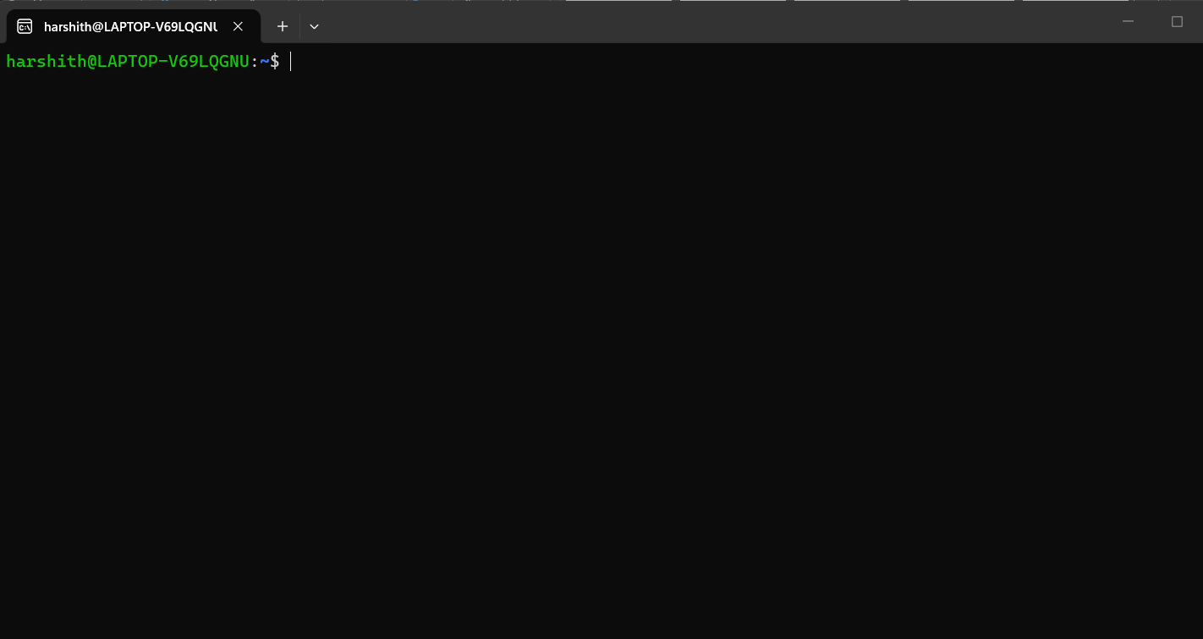

GCC compilation.

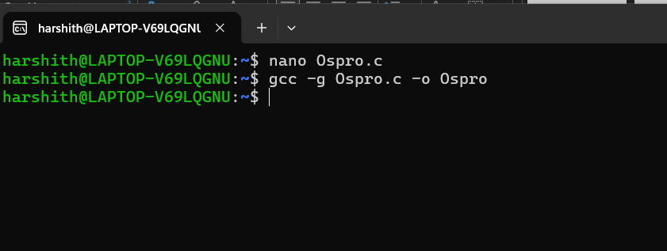

Successful execution.

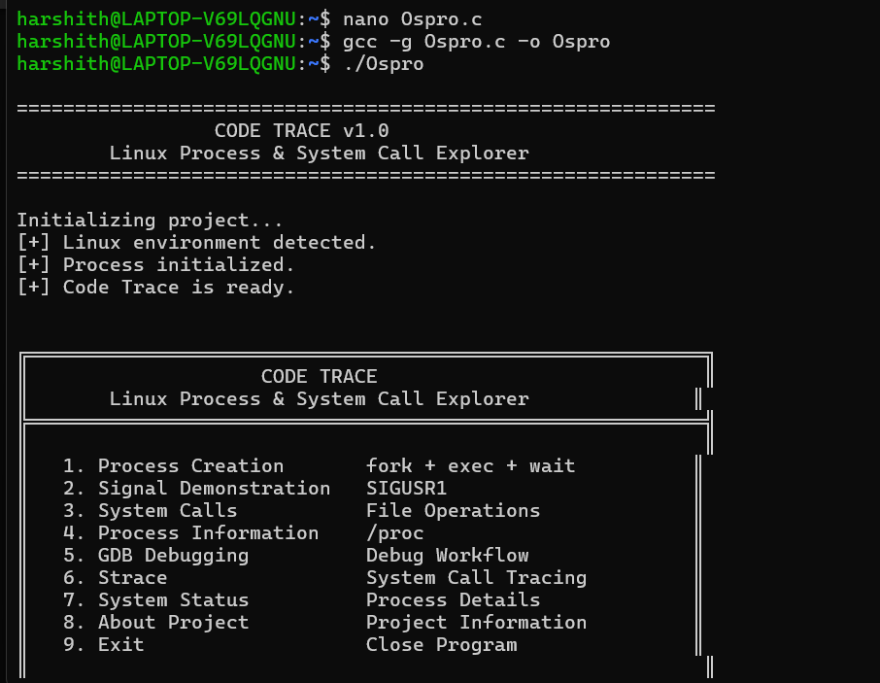

Program failure/error.

GDB startup.

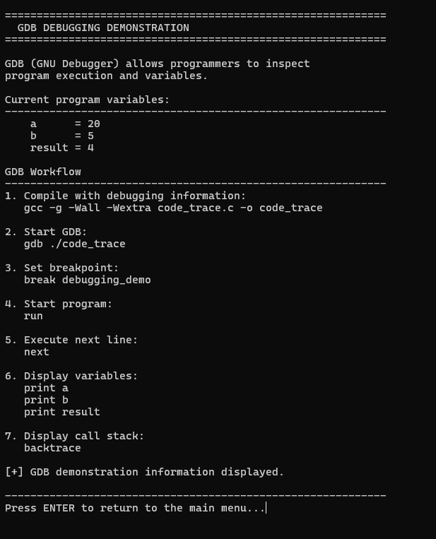

GDB breakpoint.

GDB variable inspection.

GDB backtrace.

strace output.

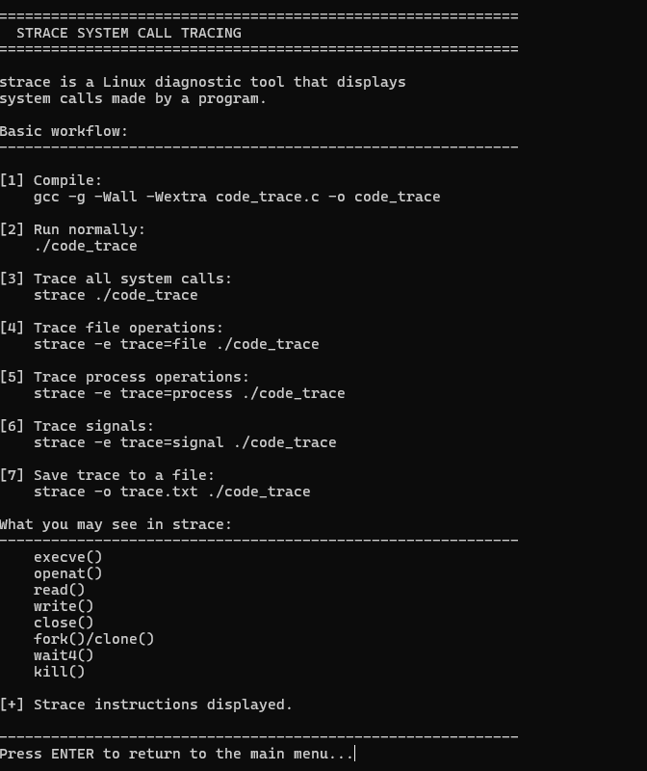

Process information using /proc.

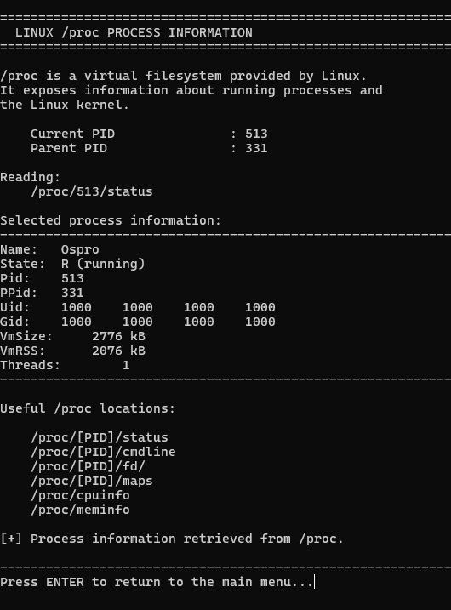

7.5 Demonstration of OS Concepts

The final demonstration should show:
OS Concept | Demonstration
Process | Execute a C/C++ program
Process Creation | fork()
Program Execution | exec()
Synchronization | wait() / waitpid()
Signals | Observe abnormal process events
System Calls | strace
Process Information | /proc
Debugging | GDB
Kernel Interaction | System-call tracing

Chapter 8 – Conclusion

8.1 Summary of the Project

The Code Trace: Inside Linux Processes & System Calls project provides a practical Linux-based approach to understanding program execution, debugging, processes, and system calls.

The project combines GDB and strace to investigate problems at both the source-code and operating-system levels.

8.2 Objectives Achieved

The project achieves the following objectives:

Linux-based debugging workflow was developed.

C/C++ programs can be debugged using GDB.

System calls can be traced using strace.

Runtime errors and abnormal behavior can be analyzed.

Process creation and synchronization can be studied.

Signals and process states can be investigated.

Linux kernel interaction can be observed.

8.3 Results Achieved

The expected project results include useful debugging information such as:

Breakpoints

Variable values

Stack traces

Process behavior

Signals

System-call traces

The project proposal specifically states that the final outcome should demonstrate how Linux debugging tools help locate and understand programming and process-level problems.

8.4 Skills and Learning Outcomes

Through this project, students gain practical knowledge of:

Linux

C/C++ programming

GDB

strace

System calls

Process management

Signals

Process synchronization

/proc filesystem

Debugging techniques

Linux command-line tools

Chapter 9 – References

9.1 Books

Abraham Silberschatz, Peter B. Galvin, Greg Gagne, Operating System Concepts.

W. Richard Stevens, Stephen A. Rago, Advanced Programming in the UNIX Environment.

Robert Love, Linux System Programming.

9.2 Research Papers

Include research papers related to:

Linux process management

System-call tracing

Operating-system debugging

Process monitoring

Linux performance analysis

9.3 Linux / GNU Documentation

Recommended documentation:

GNU GDB Documentation

Linux man pages

GNU Compiler Collection documentation

Linux system-call documentation

POSIX documentation

strace documentation

9.4 Online Resources

Useful resources include:

GNU/Linux documentation

Ubuntu documentation

GNU GDB documentation

Linux man pages

POSIX documentation

GitHub project repository

Your submitted project form gives the project repository as:

